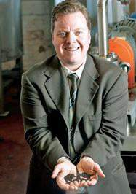
Dear Hiring Executive,

I have over 20 years of experience in manufacturing with over 15 of those years being in automotive manufacturing. This includes leading single facilities of over 500 employees as well as multiple facilities with more than 2,000 employees. Building new facilities, launching new products and turning around existing operations are the areas where I have excelled the most.

My career path follows directly from operator to production supervisor, through various industrial engineering, quality management, new product launch roles. This was followed by positions as: assistant plant manager, plant manager, general manager, and VP of Operations with over $300 million in P&L responsibility across multiple facilities.
Crain's Detroit Business 2011
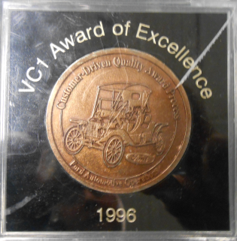
Regardless of the level of operations position I have held, all have required hands-on shop floor management including product design, production scheduling, quality problem solving, bottleneck removal, equipment repair and upgrade, energy reduction initiatives, automation installation, and industrial engineering including workforce reduction oversight. Most recently, I was involved in the direct development, installation, and operation of a biofuel facility. Innovations in continuous processing, chemical separation, material handling, and even a patented feedstock production process came from direct work on the production floor.
Ford Vehicle Operations 1996
At each leadership role, I have improved productivity, quality and safety. Several of these assignments included quality and financial turnarounds. I have worked with nearly every automotive OEM domestically and internationally.

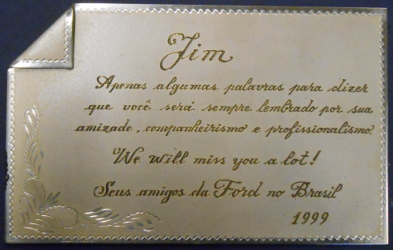
Manufacturing process improvement has defined my career from the beginning. I was tasked with taking over the Chassis Subsystem at the Ford Wayne Assembly Plant. Through a series of process improvements, we managed to turn around our quality performance from worst-in-Ford to best-in-class across all automakers. I received the Ford VC1 Award of Excellence for this endeavor. These same skills were applied during my time with Ford in Brazil launching the P131 and H215 medium and heavy duty truck programs as well as several cab-over engine programs. All programs launched on time and under budget.
Ford Brazil 1999
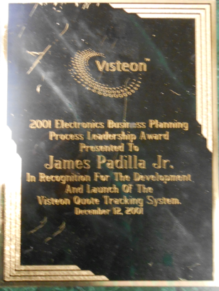
Similarly, I have also led business process improvements. When I worked at Visteon we had recently separated from Ford Motor Company. Visteon lacked the control systems to effectively understand their cost structure as well as the global communications tools to effectively market new electronics products. I was able to design, develop, and launch web-based systems which allowed the Electronics Division to track and manage its businesses. This resulted in my receiving the 2001 Business Planning Process Leadership Award.

I have lived, studied, and worked in Europe and South America and have travelled and done business in Asia. My wife is a Belgian national and my oldest son was born in Brazil. I speak fluent English, Portuguese, French, and understand Spanish. I also have a strong academic background which includes three master’s degrees and university level teaching. Specifically, I was recently solicited to teach supply chain management (including The Theory of Constraints) at the graduate level at the University of Detroit-Mercy. Currently, I am teaching IT classes there.
Visteon Electronics 2001

All of this means the capability to improve your operations, business systems, and develop personnel.

I would welcome the opportunity to speak with you regarding this position.

